Ideation Phase
Brainstorm & Idea Prioritization Template
Date | 16 September 2026
Team ID | Individual Project
Project Name | Employee Issue Management – Record Producer and Service Portal Integration
Maximum Marks | 4 Marks

Brainstorm & Idea Prioritization:
To address the inefficiencies of email-based workplace issue tracking, I explored methods to standardize request intake, ensure data integrity, and automate ticket handling in ServiceNow. After grouping requirements into intake UX, validation rules, assignment logic, and auditability, I selected an architecture centered on a Service Portal Record Producer feeding into a custom Employee Issue table. This approach leverages Client Scripts and UI Policies for client-side field dependencies, along with Business Rules and Data Policies on the backend to automate issue prioritization, routing, and tracking.
Step-1: Team Gathering, Collaboration and Select the Problem Statement
Employees need a standardized and centralized way to report workplace issues (payroll, access, infrastructure, HR policy). The system should validate user input, enforce dynamic field dependencies, and automatically prioritize and assign tickets to the appropriate support teams.
Problem Statement : The existing manual workplace issue reporting process relies on emails and informal communications, requiring separate communication steps, causing inconsistent data capture, and leading to delayed resolutions. A ServiceNow-based solution is proposed to capture employee issue details through a Service Portal Record Producer, enforce dynamic client and server-side validations, and automatically manage prioritization, assignment, and status tracking.
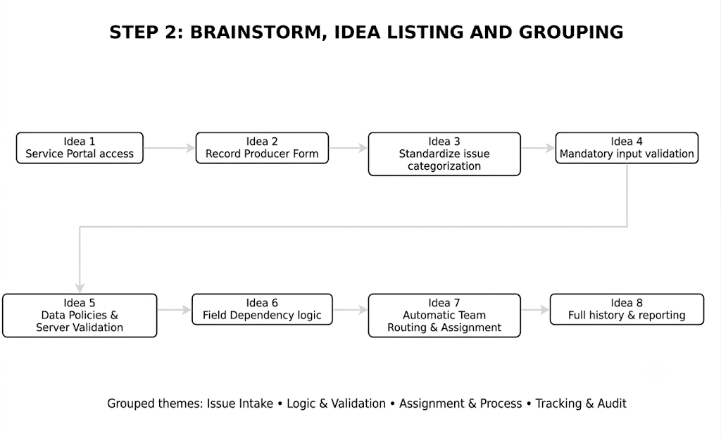
Step-2: Brainstorm, Idea Listing and Grouping

Grouped Themes:
- Issue Intake: Service Portal access, Record Producer form, standardized issue categorization, request status tracking.
- Logic & Validation: Mandatory input validation, dynamic field dependencies, UI Policies, server-side Data Policies.
- Assignment & Process: Automatic support team routing, priority determination, business rules execution.
- Tracking & Audit: Full issue history, requester notifications, resolution tracking, audit log.
Step-3: Idea Prioritization
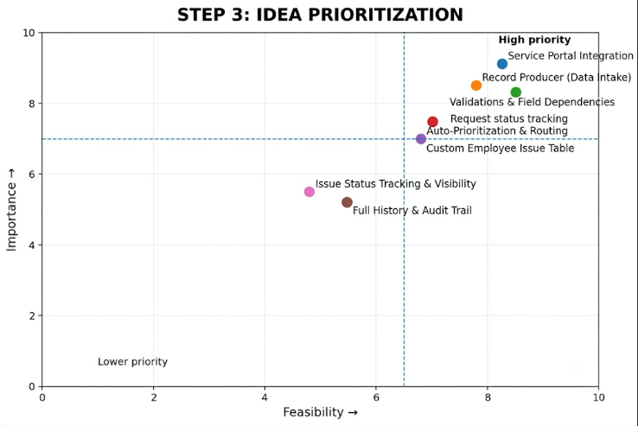
Prioritization was evaluated using importance and feasibility metrics. The Service Portal Integration, Record Producer, and Client/Server Validations & Field Dependencies were selected as core priorities because they directly enable a standardized intake process, ensure high data quality, and automate issue categorization and routing within ServiceNow.

Selected Concept
ServiceNow Employee Issue Management Workflow: An employee submits a workplace issue (such as payroll, access, infrastructure, or HR policy concerns) through a Record Producer on the Service Portal. The application executes client-side validations via Client Scripts and UI Policies to enforce dynamic field dependencies and ensure accurate data intake. Upon submission, a record is generated in the custom Employee Issue table, where server-side logic (Business Rules and Data Policies) calculates ticket priority, automatically routes the issue to the designated support team, and provides real-time status tracking for the employee through resolution.

